Section B: Method Comparison

An upgraded reagent for progesterone for your analyser was due to be released, and needed to be evaluated. You planned the assay performance verification and method comparison to be performed.

Precision and accuracy studies were performed, using the CLSI EP15-3 document.

A method comparison was performed by the technologist. Unfortunately, the laboratory ran out of old reagent before the study could be completed and they now require a quick decision from you regarding whether they can go over to the new assay.

You are provided with the following:
- Precision and accuracy data
- Method comparison data
- Progesterone package inserts - old and new
- Proficiency testing materials’ package inserts
- Allowable error limits data
- CLSI EP15-2A document

Questions:
- Complete the precision and accuracy evaluation.
- Complete the method comparison and all relevant plots.
- Using the available data, analyse the EP15-3 data and method comparison and decide whether the performance of this assay is clinically acceptable. Show all graphs and discussion.
- Comment on the manner in which the evaluation was performed.

Memo:

Complete precision and accuracy data:
Insert into data sheet 1:
- Expected target means and lower and upper limits from IQC materials [4]
- Assay characteristics [4]
- Medical decision limits and justify [4]
- Manufacturer’s claims from Prog III package insert [4]
- Error limits [4]

No marks for calculations as they happen automatically. Marks for comments:
- Repeatability and reproducibility, wrt manufacturer’s claims and allowable CV% [5]
- Bias and total error [5]

Marks for approach and comments on:
- Method comparison [5]

Plots: [5]
- Linear regression
- Absolute difference plot
- Relative difference plot

Questions:

- lmprecision is not within manufacturer's claim. However, it is within the allowable CV and is therefore acceptable.

Progesterone variation is expected to be high. Bias is within allowable limits for level 2 and 3. Bias at lowest level is high, however this is not clinically relevant. And still within the total allowable error.

Method comparison: see linear regression graph and absolute and relative difference plots. Good correlation, with large variation at very low levels.

Medical decision limits are at 3.5 (luteinising uterus for NF), 30 (day 21 - ovulating). The bias between the two assays at the lower medical decision limit is high, however reference intervals have also changed. See graphs — good correlation, except at lower concentrations. Go ahead with assay.
[5]

- Method comparison had too few samples (only 17 vs 40) and although it did not cover the entire range of physiological results, it covers the range associated with important decision limits mentioned in (b). However good correlation, and appropriate values tested for EP15-3 study.
[5]

Extra notes:

Assay changes from Progesterone II to Progesterone III:

- New calibrator
II= mouse monoclonal; III = sheep monoclonal

- Measuring range change:
II = 0.095 – 191 nmol/L
III = 0.159 – 191 nmol/L

- LOQ = 0.636 nmol/L

- Diluent still the same= E2/Prg 1:10 manual

- Traceability to ID-GC/MS
II vs ID-GC/MS: y = 0.97x + 0.26 (ng/ml) =0.97x+0.827 (in nmol/L)
III vs ID-GC/MS: y = 0.912x + 0.610 (ng/ml) = 0.91x + 1.94 (in nmol/L)

- Reference intervals have changed:

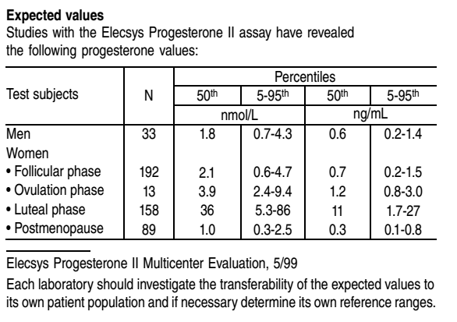

Expected values Prog III:
Test subjects | N | 5th percentile (nmol/L) | 95th percentile (nmol/L)
Healthy men | 147 | <0.159 | 0.474
Healthy women:
Follicular phase | 117 | 0.181 | 2.84
Ovulation phase | 38 | 0.385 | 38.1
Luteal phase | 126 | 5.82 | 75.9
Post-menopause | 142 | <0.159 | 0.401

 | OLD ASSAY |  | NEW ASSAY
Test subjects | 5th  percentile (nmol/L) | 95th  percentile (nmol/L) | 5th  percentile (nmol/L) | 95th  percentile (nmol/L)
Healthy men | 0.7 | 4.3 | <0.159 | 0.474
Healthy women:
Follicular phase | 0.6 | 4.7 | 0.181 | 2.84
Ovulation phase | 2.4 | 9.4 | 0.385 | 38.1
Luteal phase | 5.3 | 86 | 5.82 | 75.9
Post-menopause | 0.3 | 2.5 | <0.159 | 0.401

