Calculation 1:
[8 marks]

A suggestion is made to screen men for prostate cancer using a single prostate-specific antigen (PSA) measurement. Your local urology colleagues wish to calculate the potential impact of the proposed screening program on clinic numbers. Assume that all patients with values of more than 4 μg/L will be referred to the clinic.

The best local estimates available are an eligible population to be screened of 20 000 men and a prevalence of prostate cancer of 3%.
The diagnostic sensitivity for prostate cancer of a PSA of more than 4 μg/L is quoted to be 67% and the specificity 97%.

Using the information provided:
(1) How many patients will be referred? (2)
(2) How many of these will have prostate cancer? (2)
(3) What is the diagnostic efficiency (positive predictive value) of PSA of more than 4 μg/L? (2)
(4) What is the negative predictive value of PSA of 4 μg/L or less? (2)

Calculation 2:
[5 marks]

You are setting up an assay for serum adenosine deaminase in which 20 uL of serum is first equilibrated at 37°C with 1.5 mL of buffer in a cuvette with 0.5 cm light path. The reaction is initiated by adding 25 uL of substrate then monitored by measuring the rate of decrease in absorbance at 265 nm. Both substrate and product absorb at this wavelength with the absorbance of inosine being 43% of that due to adenosine. Derive a factor to convert the rate of absorbance change (per minute) to units of adenosine deaminase activity (expressed as umol inosine/min/L serum). The molar absorptivity of adenosine is 13,400 L.cm⁻¹.mol⁻¹.

Deacon’s 199 Dec 2018:

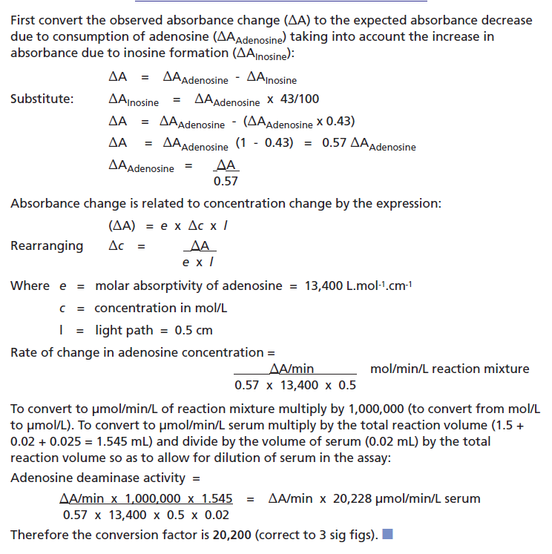

Calculation 3:
[5 marks]

A patient in A&E with suspected adrenal crisis was given an iv dose of hydrocortisone at 18.00. The medical team on take wish to carry out a short synacthen test to confirm the diagnosis but there will be a significant contribution from the administered drug until its concentration has fallen to 10% of the peak value. Assuming that hydrocortisone elimination follows a single compartment (first order) model with a half-life of 2 h, what is the earliest time at which the test can be carried out?

Deacon’s 193 Dec 2017:

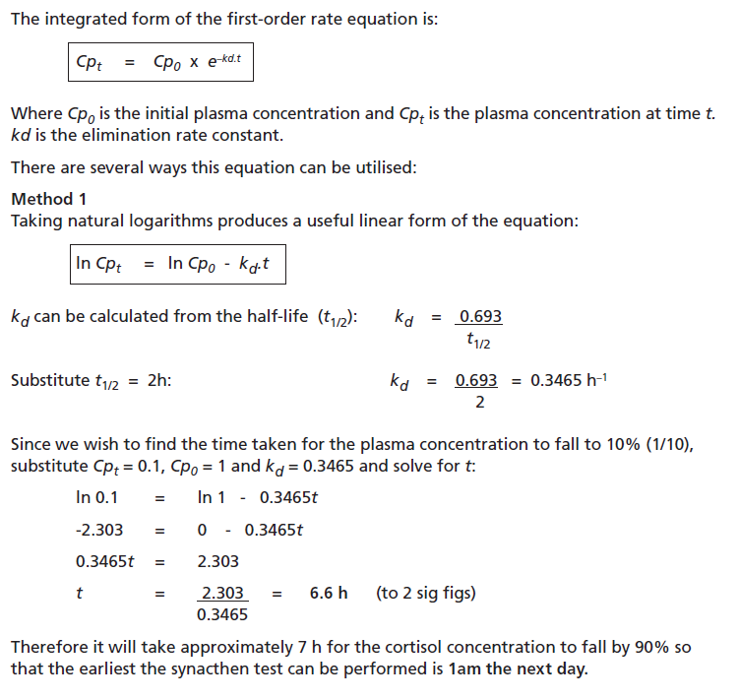

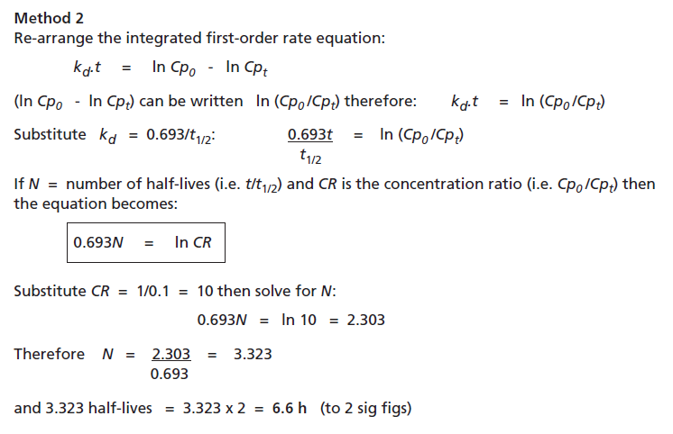

Calculation 4:
[7 marks]

The following results were obtained for a neonate weighing 1.06 kg:
pH = 7.143
PCO2 = 5.02 kPa

The consultant gives the child a 6-mL bolus of sodium hydrogen carbonate 4.2%. The child is ventilated and no changes are made to the ventilator settings. Calculate the anticipated change in pH.

Assume that the body water in infancy is 80% of the body mass, evenly distributed between intracellular and extracellular compartments.

Tietz Deacons Q123

